THEORY QUESTIONS
1.
(a)

ABC supermarket has acquired an application to generate cash receipts for goods purchased by its customers as shown in the diagram below.
The amount for each item is obtained by multiplying the unit price and quantity of goods purchased.
The subtotal is a summation of the amounts obtained for all purchased items. The tax payable is computed at a rate of 10% of subtotal.
The total amount to be paid is the summation of the subtotal and the tax payable on purchased items.
Using the diagram below, answer the questions that follow.
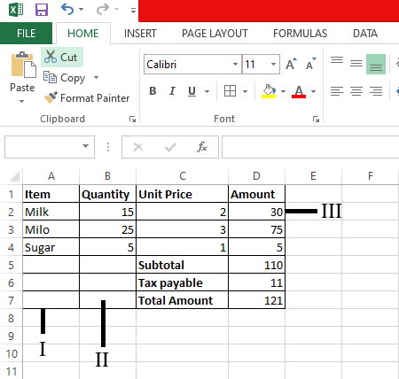
(i)

Name the application program used in creating the document above.
(ii)

Identify the part labelled I, II and III.
(iii)

Provide the formula used in calculating the following cells
D2 ............................................
D5 ............................................
D6 ............................................
(b)

Use the diagram below to answer questions (i), (ii) and (iii).
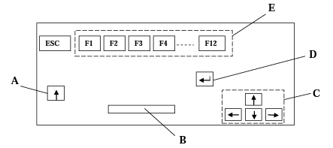
(i)

Identify the diagram above.
(ii)

Name the parts labelled A, B, C, D and E
(iii)

State one function each of the parts labelled B and C in the diagram in (b).
(c)

State one function of the diagram identified in (b)(i).

2.
(a)

State two positive uses and two negative uses of the internet.
(b)

List four storage media.

3.
(a)

Explain communication as used in the computer industry.
(b)

Video conferencing refers to:
(c)

List two devices associated with video conferencing.
(d)

State four media for sending and receiving information.

4.
(a)

In word processing application, when is it appropriate to use:
(i)

copy-and-paste;
(ii)

cut-and-paste;
(b)

(i)

What is a font?
(ii)

List three font styles

5.
(a)

What is:
(i)

Motherboard;
(ii)

Ergonomics;
(iii)

Menu bar.
(b)

What is copyright used for?

